
Nursery Newsletter – July 2026
Dear Parents and Carers,
We have had a busy, fun-filled end of term enjoying the sunshine with lots of outdoor fun, sports, games and activities.
The children have had a fantastic academic year, and we are incredibly proud of them all, we have enjoyed watching them thrive in development and confidence.

** Please be reminded the last day of term is Friday 17th July, returning
Thursday 3rd September 2026 **
Transitions to School
All the staff at Shine would like to wish all our leavers the best of luck in your new settings. We have enjoyed being part of your educational journey and hope you continue to grow and thrive. It has been a great pleasure getting to know you and your families. We will miss you all.

Nursery Contact
If you need to contact the nursery, please always phone the office on 01493 661000 or email nursery@shine-gy.org.uk. Please do not send messages via Tapestry as this is not continuously monitored.

Home Learning
Attached are some home learning activities. We would love you to share your activities on Tapestry or return them to nursery.

Tapestry
Thank you to all the families that engage with Tapestry. Tapestry allows us to share an overview and reflection of your child’s learning journey so that you as parents/carers are aware of where your child is with their learning and development. Please speak to a member of staff if you have any issues accessing Tapestry.

Dummies and Bottles
Thank you to all the parents who have supported our setting in reducing the use of bottles and dummies. This is especially important for those children starting school in September. If you need any support please speak to Laura, Joanne or Nicola.

Spare Clothes
Please make sure children are coming to nursery with a named waterproof coat, wellies, hat and gloves when necessary. As part of our learning, children have daily access to our outdoor area throughout the session to experience different learning opportunities, therefore will need the appropriate clothing to make sure they are warm and dry.

Thank you!
The staff at Shine would like to say a BIG thank you for all the kind words, cards and gifts you have shared with staff, it is much appreciated.
We hope you all have an amazing summer.



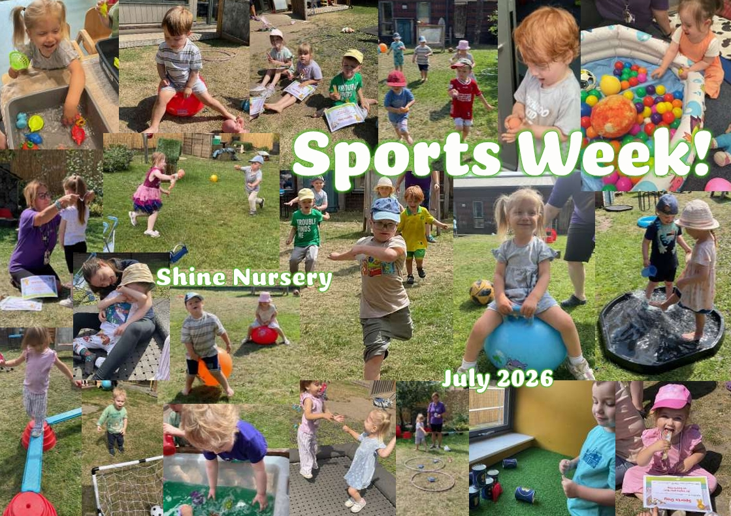


*** Important reminders ***
- Please provide a drink, nappies, wipes, and spare clothes for each session.
- Ensure everything brought into the setting is named, this will ensure a swift return.
- If your child is sick or will be absent, please call or email the office ASAP on 01493 661000 / info@shine-gy.org.uk. This helps us to know that the children are safe.
- Please let a member of staff know if you cannot access your Tapestry account.
- We are strictly a NO NUT setting.
- Due to the impact of ratios (children to staff) please ensure your child is dropped off/collected promptly and you remain outside the setting using the doorbell to alert staff.
- Don’t forget to follow us on Facebook – Shine The Nursery.
Dates for the diary 2026/27
Friday 17th Jul - Last day of term 🌞

Monday 27th Jul - Coffee morning 10-11am ☕
with Family Hubs and School & Community Team (East)

Thursday 3rd Sept - Return to nursery
Thursday 22nd Oct - Last day of term

Monday 2nd Nov - Return to nursery
Friday 18th Dec - Last day of term 🎄

Tues 5th Jan 27’ - Return to nursery

