
Nursery Newsletter - May 2026

Dear Parents and Carers,
We have had a busy term enjoying the musical instruments, making rain sticks, messy play, wet play and having lots of fun exploring the garden.

Staff Changes
We are sadly saying goodbye to Sue and Donna this term. We would like to thank them both for all their hard work throughout their time at Shine and wish them every success in their future endeavours.
We are pleased that Imarni has now finished her studies and will increase her days in the Nursery.
Kerry has been working with the Short Breaks team for a while now and we are delighted to be seeing a lot more of her in the Nursery now too.

Kerry
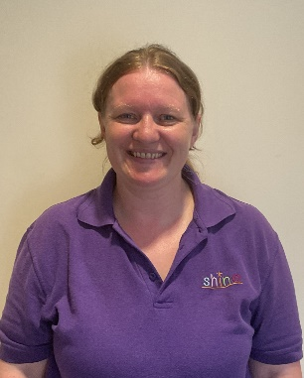

Key Person Catch-ups
If your child has a final EHCP this will be reviewed with your child’s transitioning school before the end of the summer term. If you would like to meet with your child’s key person for a catch-up, please let a member of staff know so we can make an appointment.

*** IMPORTANT ***
Suncream
As we are now experiencing warmer weather please can we remind you to apply sun cream on your child before bringing them to Nursery and ensure they have sun cream and a hat (marked with their name) in their bag.

Headlice
We are aware of head lice in the nursery. Because head lice can spread quickly through close, head-to-head contract, we are asking all parents to check their children’s hair.
What to look for
Head lice are small insects (about the size of a sesame seed) that live in hair, and nits are the eggs. They are often found near the scalp, behind the ears, or at the nape of the neck.
Action required
- Check: Please check your child’s hair thoroughly, preferably using a fine-toothed comb (wet combing).
- Treat: If you find live lice, treat your child immediately with a recommended product from a pharmacy or through wet combing.
- Prevent: A second treatment is often required 7-10 days later to kill any lice that have hatched since the first treatment.
- Notify: Please inform us if your child has lice, so we can continue to monitor the situation and help manage the spread.
Remember, head lice are a common, treatable issue that affects many children, and it is not related to personal hygiene.
Thank you for your cooperation in keeping our setting healthy.

Nursery Contact
If you need to contact the nursery, please always phone the office on 01493 661000 or email nursery@shine-gy.org.uk. Please do not send messages via Tapestry as this is not continuously monitored.

Home Learning
Attached are some home learning activities. We would love you to share your activities on Tapestry or return them to nursery.

Tapestry
Thank you to all the families that engage with Tapestry. Tapestry allows us to share an overview and reflection of your child’s learning journey so that you as parents/carers are aware of where your child is with their learning and development. Please speak to a member of staff if you have any issues accessing Tapestry.

Dummies & Bottles
Thank you to all the parents who have supported our setting in reducing the use of bottles and dummies. This is especially important for those children starting school in September. If you need any support please speak to Laura, Joanne or Nicola.

Spare Clothes
Please make sure children are coming to nursery with a named waterproof coat, wellies, hat and gloves when necessary. As part of our learning, children have daily access to our outdoor area throughout the session to experience different learning opportunities, therefore will need the appropriate clothing to make sure they are warm and dry.
We ask that all children bring in spare named clothes for water play and especially if they are toilet training. We have a limited supply of spares. If your child does bring home clothing from Shine, please can it be returned as soon as possible.

** Please be reminded the last day of term is Friday 22nd May, returning Monday 1st June 2026 **

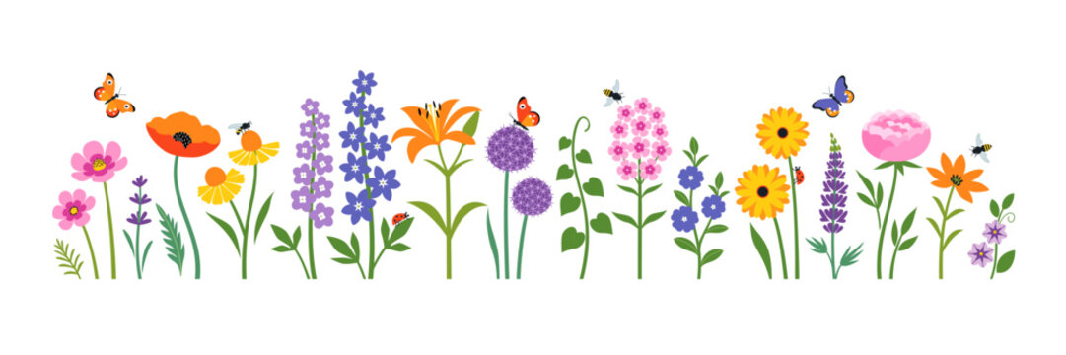

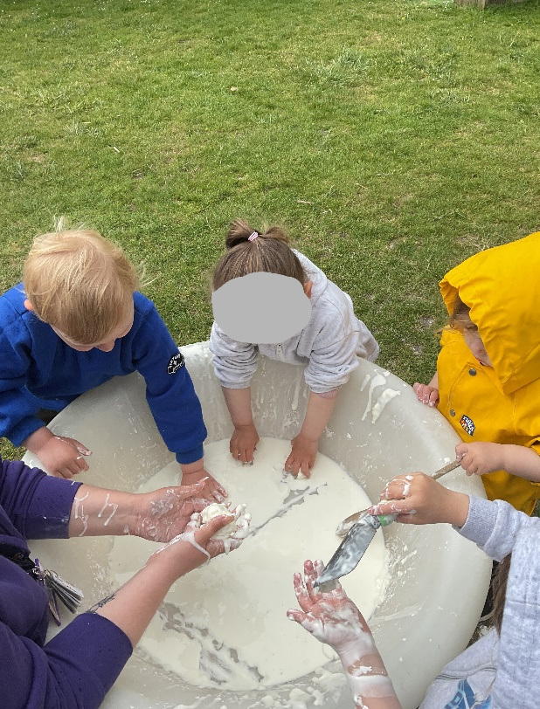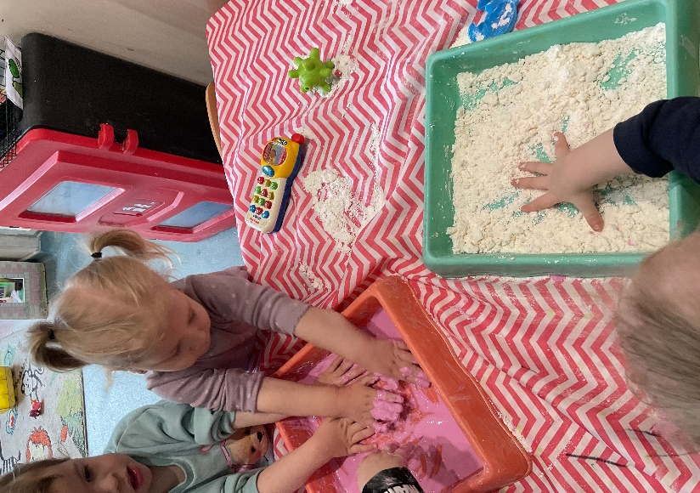

Dates for the diary overleaf
Important reminders
- Please provide a drink, nappies, wipes, and spare clothes for each session.
- Ensure everything brought into the setting is named, this will ensure a swift return.
- If your child is sick or will be absent, please call or email the office ASAP on 01493 661000 / info@shine-gy.org.uk. This helps us to know that the children are safe.
- Please let a member of staff know if you cannot access your Tapestry account.
- We are strictly a NO NUT setting.
- Due to the impact of ratios (children to staff) please ensure your child is dropped off/collected promptly and you remain outside the setting using the doorbell to alert staff.
- Don’t forget to follow us on Facebook – Shine The Nursery.

Dates for the diary 2026/27

Monday 1st Jun - Return to nursery
Monday 6th Jul - ‘Tackling Transitions’ Workshop 1-2pm
Mon 6th-10th Jul - Sports week
Mon 13th-17th Jul - Party week
Friday 17th Jul - Last day of term 🌞

Monday 27th Jul - Coffee morning ☕

Thursday 3rd Sept - Return to nursery
Thursday 22nd Oct - Last day of term

Monday 2nd Nov - Return to nursery
Friday 18th Dec - Last day of term 🎄

Tuesday 5th Jan 27’ - Return to nursery

