

February 2026 Newsletter

Dear Parents and Carers,
The staff at Shine would like to say a big thank you for all the kind, Christmas wishes and gifts you shared, its much appreciated.
We have had a great start to 2026. The children have settled back into nursery well and have been busy with lots of fun and activities. The focus this term has been ‘communication’ - working towards the children’s individual targets by using more visual aids and Speech Sound games.

For the safety of our children please do not send them in with metal drinks bottles/flasks (Stanley, Thermos etc) - plastic only, thank you.

Dental Care
In early years we have a duty to promote healthy teeth and preventing tooth decay. Attached is a survey about your child’s dental care, if you could complete this and return it to nursery that would be useful. Bottle teats, dummies, and juice can greatly impact children’s teeth. If your child is currently using one of these, you should consider the long-term impact this could be having on your child’s teeth. If you would like support with this, please talk to Laura or Joanne. Laura will be having group discussions and one-to-ones with parents as we want to support you as much as we can.

World Book Day
We will be celebrating World Book Day on Thursday 5th and Friday 6th March, children are welcome to dress up as their favourite characters.

Key Person Catch-ups
These will be held week commencing Monday 23rd March. If you would like to meet with your child’s key person, please let a member of staff know so we can make an appointment.

Nursery Contact
If you need to contact the nursery, please always phone the office on 01493 661000 or email nursery@shine-gy.org.uk. Please do not send messages via Tapestry as this is not continuously monitored.

Home Learning
Attached is a home learning activity. We would love you to share your activity on Tapestry or return it to nursery.

Tapestry
Thank you to all the families that engage with Tapestry. Tapestry allows us to share an overview and reflection of your child’s learning journey so that you as parents/carers are aware of where your child is with their learning and development. Please speak to a member of staff if you have any issues accessing Tapestry.

Dummies & Bottles
Thank you to all the parents who have supported our setting in reducing the use of bottles and dummies. This is especially important for those children starting school in September. If you need any support please speak to Laura, Joanne or Nicola.

Spare Clothes
Please make sure children are coming to nursery with a named waterproof coat, wellies, hat and gloves when necessary. As part of our learning, children have daily access to our outdoor area throughout the session to experience different learning opportunities, therefore will need the appropriate clothing to make sure they are warm.
We ask that all children bring in spare named clothes for water play and especially if they are toilet training. We have a limited supply of spares. If your child does bring home clothing from Shine, please can it be returned as soon as possible.

** Please be reminded the last day of term is Friday 13th February, returning Monday 23rd February 2026 **

Happy Holidays

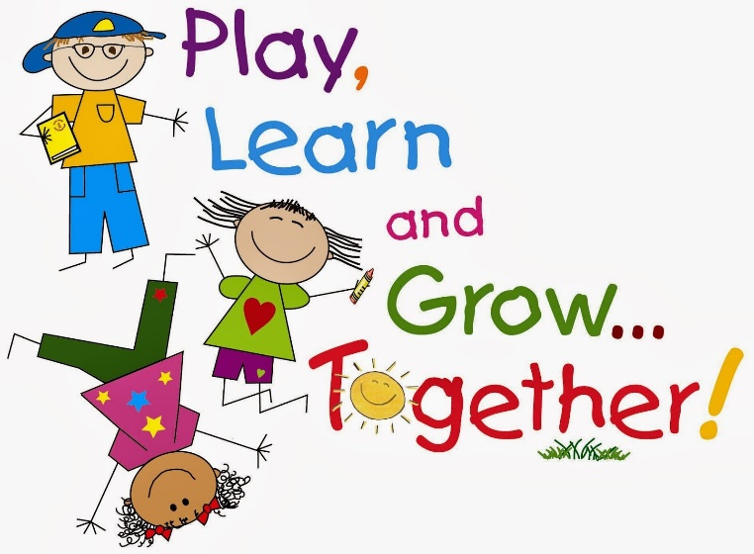
Important reminders
- Please provide a drink, nappies, wipes, and spare clothes for each session.
- Ensure everything brought into the setting is named, this will ensure a swift return.
- If your child is sick or will be absent, please call or email the office ASAP on 01493 661000 / info@shine-gy.org.uk. This helps us to know that the children are safe.
- Please let a member of staff know if you cannot access your Tapestry account.
- We are strictly a NO NUT setting.
- Due to the impact of ratios (children to staff) please ensure your child is dropped off/collected promptly and remain outside the setting using the doorbell to alert staff.
- Don’t forget to follow us on Facebook – Shine The Nursery.

Dates for the diary 2026
Friday 13th Feb - Last day of term

Monday 23rd Feb - Return to nursery
Tuesday 24th Feb - Coffee morning with Happy Smiles Club 9-10am 🦷
Thurs 5th & 6th Mar - World Book Day 📚
Mon 23^{rd -} 27th Mar - Key Person Catch-ups
Friday 27th Mar - Last day of term

Saturday 11th Apr - Shine Spring Fayre 11-3pm 🌷
Tuesday 14th Apr - Return to nursery
Monday 4th May - Bank holiday
Friday 22nd May - Last day of term

Monday 1st Jun - Return to nursery
Friday 17th Jul - Last day of term 🌞

